ST207
Databases

Candidate #:
42365
40294
39109

Project Name:
Huckletree

Word count: 3,384
Page count: 10

- Description of the Chosen Topic/Scenario:
Huckletree is a venture capital database designed to provide investors with access to large amounts of data on companies that would aid users in streamlining the investment research process. By designing a database on MongoDB and corresponding queries that provide investors with essential information based on their own investment preferences, users are able to efficiently discover required information through automated processes significant manpower and time required in their tasks is reduced.
Data on start-up's fundraising, revenues, valuation, sector and founders is essential to investors decision-making. This data exists across many data sources on the web but is useful when consolidated into a single database with all necessary data for relevant start-ups. This is the purpose of this database.
We structured our project using standard data (i.e. structured and tabular data). Our database contains information on companies, including general information such as names, domains, industries and locations. Additionally, it contains financial measures of each company such as funding revenue valuations and size based on employee numbers. Further information includes information on individual investors and GitHub repositories for tech related companies.
We had 190 CSVs of data from both paid and free sources (CrunchBase, Dealroom, LinkedIn) which we chose the 9 most important datapoints. The CSVs had 4.5 million companies, so we filtered for companies that are ‘unicorn’ status (start-ups that have a valuation of £1bn+). This is 1846 companies with over 150 datapoints on each.

- Description of your Data:
Our data was sourced privately, from Runa Capital, hence is reliable and representative of real-world companies, so we did not have to generate any synthetic data. There is sufficient info that allows us to understand how the data was captured, as the data comes from third party APIs or simple web scraping. The data is structured in a coherent manner, and we chose key tables that were relevant to our queries, which focus on helping users of the DB (i.e. investors) to better understand the global unicorn landscape and gain key information on specific companies. We accounted for missing data by filtering the data to include only unicorn countries, as for bias, our data is sourced from 3rd party APIs or web-scraping and is thus entirely factual. The main concern we had about our data sources was that some companies do not have KPI data or CrunchBase rounds, so not all companies could be queried based on valuation data, however, we worked around this concern by ensuring that the companies with no info do not interfere with any of the queries that are based around valuations. The only other bias we have is that we kept only unicorn companies, hence our queries may not completely reflect a real-world VC scenario, as we are dismissing all the smaller companies. This is a necessary sacrifice though, as without this filtering, we would be above the MongoDB size limit.

- Description of your Model:
Our Database contains 9 main entities. Below are the entity descriptions and their relationships and a description of the use of the relationships
Unicorns: This entity contains general information on companies. Relationships include:
- Employees: This is so that all employees are linked to their respective companies. Employees must and only belong to one company while unicorns may have multiple employees
- Repos: all repos are linked to their companies. Note not all companies have repositories therefore this is not a mandatory relationship from Unicorns side. Additionally, some unicorns may have multiple repositories such as skype
- Crunchbase_rounds: every funding round is linked to their parent company, additionally this relationship allows further joins with dealroom based data which contains further financial information, crucial for achieving our queries. Not all unicorns will have info on funding rounds however unicorns may have multiple funding rounds. All rounds must belong to a unicorn
- Dealroom_companies: contains further information on companies, useful in creating join queries with general company info in unicorns as well as extended info from CrunchBase and other collections through unicorns. This is a one-to-one relationship. Note not all unicorns will exist on dealroom companies but all dealroom companies will exist in the unicorn collection
- Unicorn_founders: connects essential information on founders of unicorns to unicorns. All unicorns may have multiple founders and must have one while founders may have founded multiple unicorns but must have founded one to exist on the database
- Geo_locations: Has generic data on countries and allows geospatial analysis of unicorn locations. Unicorns will have one base location however each document of a country can link to multiple unicorns as many can be based in the same location
Geo_locations: contains information on countries to allow geospatial analysis of entities with a location attribute. Relationships include:
- Unicorns: As described above
- Investors: similarly to the relationship with unicorns enables a geospatial analysis of investor hubs and locations. Similarly investors will have one location but multiple investors may be located in the same location
Dealroom_companies: Contains extended information on companies not in unicorns such as industries and investors of corresponding company. Serves as a key link to further dealroom financial data. Relationships include:
- Dealroom_kpis: contains financial information on revenue and valuation for companies at multiple time points. Relationship with dealroom companies allows timeseries analysis of financial data supplemented by all extended relationships from dealroom_companies and unicorns. Kpis are time-based data therefore companies will have multiple kpi data points at different times however a single piece of kpi data must belong to one and only one company. Additionally, not all companies will have released financial info therefore it is possible for companies to have no kpi data

- Queries:
First Query: Comprehensive Dashboard for Key Company Insights
i)Purpose of the Query
This query serves as a foundational tool to create a comprehensive dashboard that provides a detailed overview of a selected company. Its primary purpose is to enable users, such as investors or analysts, to quickly assess whether a company aligns with their investment goals or areas of interest. By integrating data from multiple collections, the query extracts and aggregates key information, including the company’s name, domain, foundation date, description, founders (along with their origins and social media links), operational locations, funding details, employee count, existing investors, and industry focus.
ii) Input parameters and conditions for filtering/matching data:
The query begins by selecting a company at random from the unicorns collection using the $sample aggregation stage. It then proceeds to enrich this data by joining it with relevant collections. To ensure clean output, null or missing values (e.g., social media links) are excluded using conditional logic ($cond and remove). Data is grouped by the selected company, with founder details consolidated into a single list containing their names, geographic locations, and available social media profiles. Finally, all relevant fields are projected to deliver a clear and concise output. Note we simply use python to format the code nicely, all the data comes from the cypher query.
iii) Outputs:
The query generates a well-structured dashboard that provides users with essential company information at a glance. This output is designed for clarity and usability, ensuring that all key details are readily accessible.
Example Output:
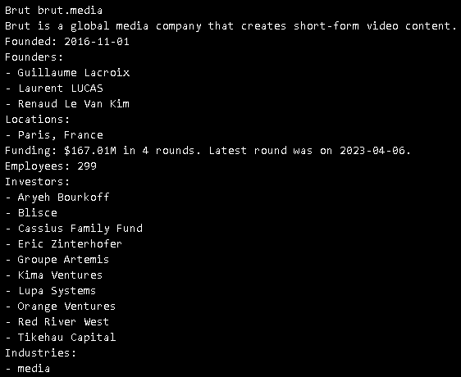
Second Query: Unicorn Companies Distribution by Continent
i) Purpose of the Query:
This query identifies the number of unicorn companies per country for each continent. It also retrieves relevant geographic and demographic data, such as country name, capital city, currency, spoken languages, and population as of 2022 from our DB. The purpose of this query is to analyse and visualize the distribution of unicorn companies by country within each continent, offering more research focused users of the DB insights into which countries and regions contribute most significantly to the global unicorn landscape.
ii) Input parameters and conditions for filtering/matching data:
The process begins by identifying all unique continents in the database, where continents are stored in a shorthand format (e.g., "EU" for Europe, "NA" for North America). Since the visualization library used requires full continent names, we had to make a manual dictionary mapping between shorthand codes and full names.
For each continent, the query processes the data through several steps. It first connects the unicorns collection with the geo_locations collection using our connection established in the database creation part (Geo_ID and _id). Only records that match the continent currently being analysed are retained using the match function. The data is then grouped by country, summing the number of unicorn companies and retrieving supplementary details such as the country's prettified name, capital city, currency, languages, and population. A sample output is: {'unicorn_count': 2, 'name': '🇨🇱Chile', 'capital': 'Santiago', 'currency': 'CLF,CLP', 'languages': "['es']", 'population2022': '19532234', 'alpha_3_code': 'CHL'}, which we then transform into an interactive map using the px library, as can be seen in the figs folder.
iii) Outputs:
The results from the query are formatted and visualized as heatmaps, with each map corresponding to a specific continent. Note, Oceania and Antarctica are excluded—Oceania due to the lack of a compatible map in the px visualization library, and Antarctica because it does not have any unicorn companies in the dataset. The heatmaps use a color-coded to represent the number of unicorn companies per country. Each country is displayed with additional hoverable details, this ensures clarity, and the scope is restricted to the continent being analysed for better focus.
Third Query: Timeseries Analysis of Unicorn Companies Worldwide Distribution Evolution Per Year
i) Purpose of the Query:
This query focuses on analysing the yearly emergence of unicorn companies globally, grouped by country and year. It retrieves both geographic and demographic data, including country name, capital city, currency, spoken languages, continent, and population as of 2022. Additionally, it captures the year each company achieved unicorn status. The goal is to provide insights into the evolution of unicorn company distribution, enabling researchers and analysts to identify trends and regional contributions to the global startup ecosystem over time.
ii) Input parameters and conditions for filtering/matching data:
The query begins by joining and processing data across three collections. The query then groups the data by both country and year, calculating the total number of unicorn companies for each combination. During this step, additional details such as the prettified country name, capital city, currency, spoken languages, continent, and population are also retrieved. The results are sorted by year to ensure the output is clear and chronologically ordered. An example of one result is: {'unicorn_count': 1, 'name': '🇬🇧United Kingdom', 'capital': 'London', 'currency': 'GBP', 'languages': "['en']", 'population2022': '67980913', 'continent': 'EU', 'country': 'GBR', 'year': 1998.0} which we then transform into an interactive map using the px library, as can be seen in the figs folder.
iii) Outputs:
The query results are visualized as a time-series choropleth map, providing an animated representation of the distribution of unicorn companies across countries over time.
Fourth Query: Cumulative funding per industry plot

This Query serves as an aggregated insight into the funding activities in industries on a year-by-year basis. This query enables users to firstly analyse the cumulative amount of funding an industry has received from a selected year until the present as well as compare the extent of funding between different industries by overlapping their plots on a graph. This can allow users to see if industries have stagnated or grown their overall funding and identify which markets are more saturated than others.

The Query takes the form of the function plot_cumulative with 2 optional user inputs
- industries: takes a list of industries that a user wishes to plot
- start_year: takes integer of year user wishes the graph to start from
default parameters provide a graph with all industries from 1996 (start of data availability in database)
Query Process:
This Query joins three collections:
crunchbase_rounds --> unicorns --> dealroom_companies

crunchbase_rounds contains the essential information on each round’s date amount raised in USD. It is than joined to unicorns through its local uni_ref attribute which linked to each unicorns unique object id. Unicorn is then joined to dealroom_companies through its local _DroomID to each dealroom_companies unique object ID in order to match each round to the respective industry that that round occurred in using the industries column in dealroom_companies.

For industries, companies may be part of multiple industries and if so they are stored as a string rather than a list, therefore using $split and $trim any data points with multiple industries were split into a list of individual industries and additional white spaces were removed. If no industry was listed, as a safety case, a conditional statement was added to return and empty list to prevent null errors for later list-based operations. For the round_announced_on column in crunchbase rounds, the dates are stored as strings therefore to enable time series analysis the dates were converted from string to date using $dateFromString" and stored as round_date as a return.

Using $group all data is grouped by their combination of year and industry and the total amount raised in each group is summed. Afterwards through conditional statements the users inputs are used to identify which industries and from what year should be plotted onto the graph and are calculated by sorting the values for each industry based on year and applying the cumsum() function to the total_raised. Column to create the cumulative_raised column. Subsequently the user is shown a plot/graph based on their input specifications.
Example usage and output:
Default:
plot_cumulative()
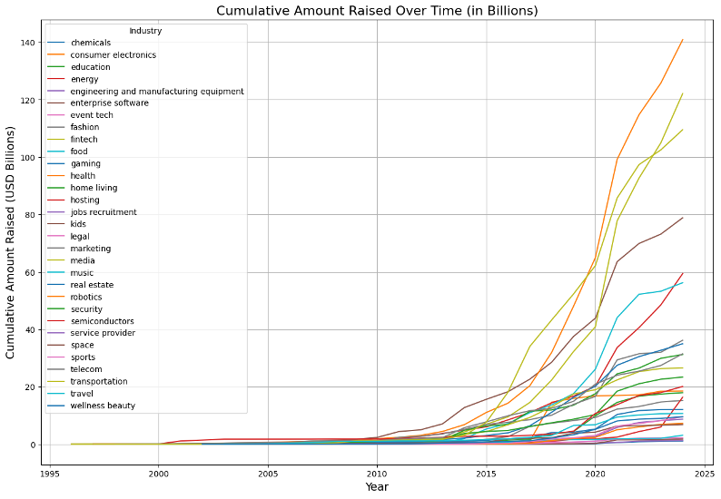

User input based:
plot_cumulative(industries=["gaming", "media",'fintech','health','enterprise software'], start_year=2010)
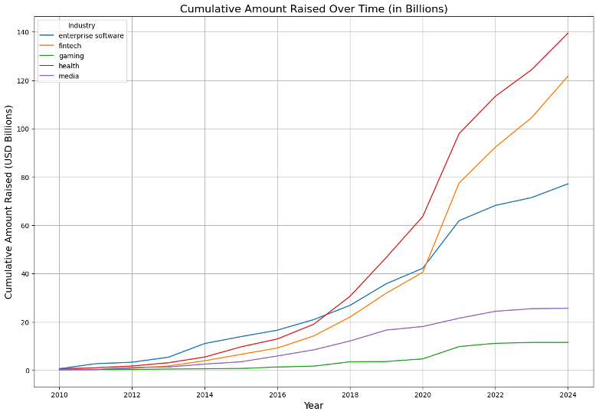

Fifth Query: Undervalued companies based on Price-to-Earnings Ratio

This query serves as a tool for users to efficiently identify undervalues companies based on their price to earnings ratio. The query takes shape as a function which enables users to specify which industry they are interested in as well as how many of the top results do they want returned. This Query returns the Valuation of the company, the revenue, the PE ratio, company name, and industry. This Query is particularly useful on such a platform as it saves man hours that would be spent on manually calculating and ranking companies based on the PE Ratio. While the P/E ratio is far from the only determinant of company valuation it is and important metric that can identify potential promising companies for investment purposes

The query uses $match to find all recently valuated companies in 2024, that don’t currently have a null valuation as well as revenue with a value of 0 as it would affect the ratio calculations. These values originate from the dealroom_kpis collection which is then joined to dealroom_companies using the local attribute dealroom_ref to link the corresponding object ids within dealroom_companies. From dealroom_companies the company names and industry are retrieved. The PE ratio is calculated within the Query dividing the valuation by the corresponding revenue. Additionally, the same code for handling industry data is used here in the same manner. The ratios are then sorted in ascending order so that the top values represent the companies with the lowest ratio signifying the most “undervalued” based on this singular metric. Using $limit the users preference on list length is implements and the query can then be returned as a data frame to the user

Example:
get_undervalued_companies('enterprise software', 5)
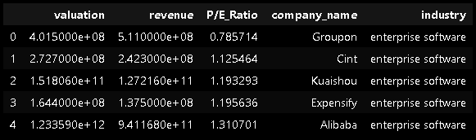

Sixth Query: Using The Vectorised Array of Company Descriptions to Show the Top 5 Similar Companies for A Chosen Company
i) Purpose of the Query:
This query aims to identify and display the top five companies whose descriptions are most similar to a randomly chosen company from the database. It uses vector embeddings, which numerically represent the meaning of company descriptions, and a vector index that enables efficient similarity searches. The query performs a vector-based search to compare the embeddings of the chosen company’s description with those of other companies. By providing a ranked list of similar companies, this query helps users explore entities with analogous business models, enabling better market research, this functionality is especially useful for database users who have worked successfully with a specific company and want to research other companies with similar characteristics.
ii) Input parameters and conditions for filtering/matching data:
The input begins with the selection of a random company from the unicorns collection (this can easily be changed to matching a specific company), achieved using the $sample aggregation stage. The selected company’s name, domain, description, and vector embedding are retrieved. The vector similarity search is implemented with the $vectorSearch pipeline stage.
iii) Outputs:
The query produces a ranked list of the top five companies similar to the chosen company based on description. An example output is:
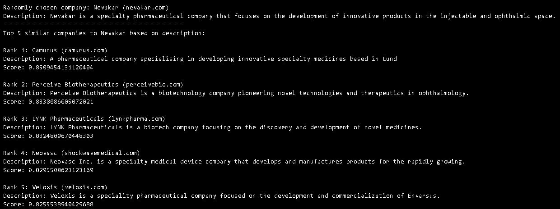
Seventh Query: The Same as The Previous Query, But Adding a Manual Employee Similarity Normalisation Score to Incorporate the Size of The Company into The Similarity Ranking
i) Purpose of the Query:
This query builds upon the previous one by incorporating an additional dimension to the similarity ranking: company size. While the primary focus remains identifying companies with descriptions similar to a randomly selected company, this version integrates an employee count similarity score. This enables DB users to find not only companies with similar business models but also those of comparable size.
ii) Input parameters and conditions for filtering/matching data:
The query begins by selecting a random company from the unicorns collection, retrieving its description, name, domain, and employee count (via the dealroom_companies collection). To calculate size similarity, the maximum difference in employees across all companies in the database is retrieved and compared to the chosen company. The combined similarity score is computed by assigning weights to the vectorised description similarity score (70%) and normalized employee similarity score (30%). The results are then sorted in descending order by this combined score, with the top 5 most similar companies returned using the limit keyword.
iii) Outputs:
The query outputs a ranked list of companies similar to the randomly chosen company, factoring in both description similarity and size proximity.
Example Output:
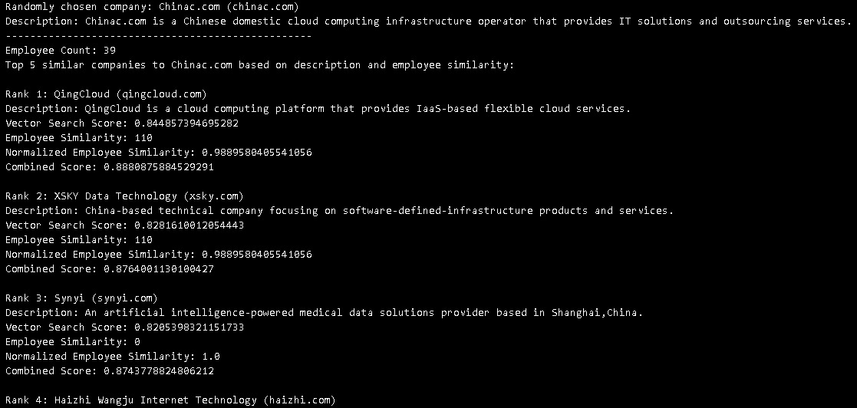
- Justification of the Database Technology/Tool
We chose MongoDB for our VC scenario since it aligns seamlessly with the requirements of a globally distributed database, where venture capitalists need remote access, rapid querying, and flexible schema designs to handle dynamic data. MongoDB supports cloud hosting, enabling remote access for all group members, mimicking how venture capitalists from across the globe would query the database in real-world applications. We enabled access to IP 0.0.0.0, which allows unrestricted access for everyone with the URI. This simulates a real-world scenario where investors and analysts access centralized data from various locations. The NoSQL nature of MongoDB allows us to store diverse, evolving datasets in a single database. For example: funding rounds and performance KPIs have different data types and structures, which MongoDB accommodates without requiring rigid schemas. This is critical in venture capital databases, where data can vary significantly depending on the investment stage, sector, or geographical region. Its native support for APIs and integrations with Python allowed us to seamlessly integrate MongoDB with our Python scripts, making it easy to load data, perform advanced queries, and generate insights programmatically. While we faced a size restriction of 512MB on MongoDB Atlas's free tier, our trimmed-down dataset (focused on unicorns and key tables) demonstrates MongoDB’s ability to handle large, complex datasets effectively.
To replicate our database and application:
No MongoDB account or software installation is required. All necessary data manipulations, libraries and queries are included in the provided Python notebook. The notebook includes a MongoDB connection URI at the top for direct access to our trimmed-down database (note: we know sharing the URI openly is not best practice, but it ensures you can easily access the database for evaluation purposes). The filtered_data folder contains all CSV files required to populate the database. These files represent the cleaned and trimmed dataset that aligns with MongoDB’s free-tier size limitations. Follow the Python notebook step-by-step to reproduce our work. The notebook covers: setting up a connection to MongoDB using pymongo, populating collections from the CSV files and running all our queries.
Technical Restrictions
MongoDB Atlas’s free tier imposes a 512MB storage limit. To comply, we trimmed the dataset to focus on unicorn companies and key tables relevant to our use case. The original dataset was 69GB.
Additionally, MongoDB tends to be less efficient in memory usage than relational databases as field names are individually stored in each document rather than one-time used in the normal tabular format
Moreover, MongoDB does not support traditional join mechanisms and uses $lookup function, however it does provide similar results and functionality and did not prevent us from achieving the desired results queries

